### Aim: To study about Java script

1.      Write a JavaScript to display “Welcome to UVPCE” in web page.

**Source:**

 <html>

<head>

<script type="text/javascript">

document.write("Welcome to UVPCE")

</script>

</head>

<title>prectical11-1

</title>

<pre></pre>

</html>

**Output:**

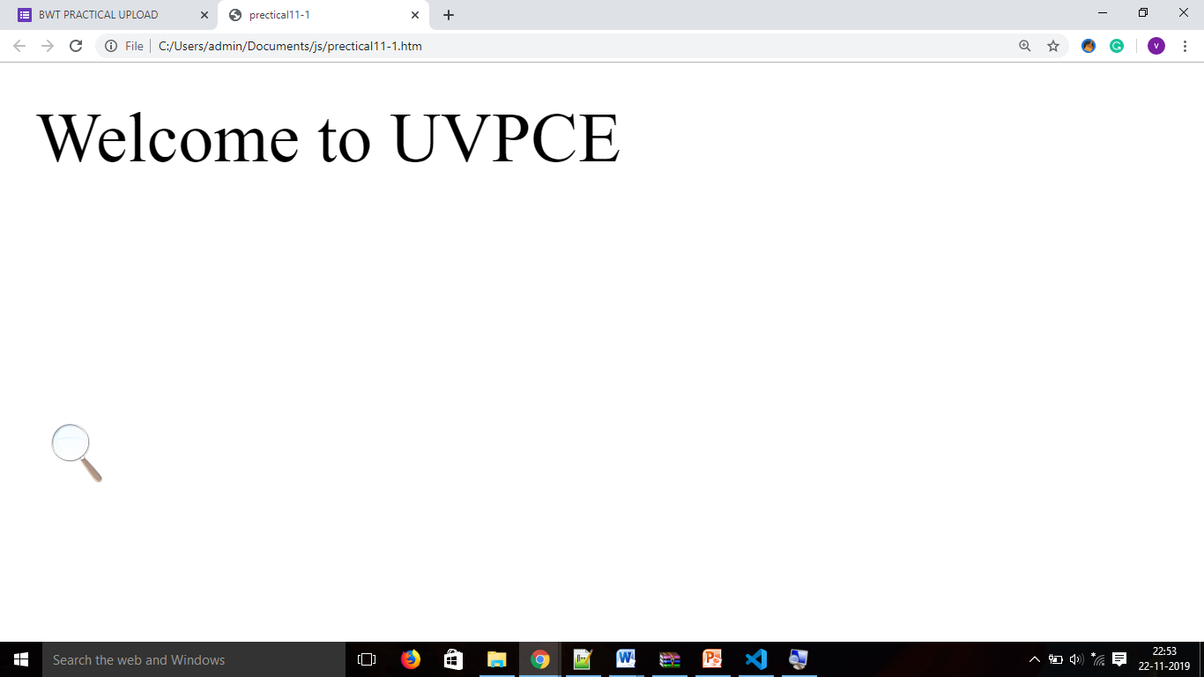

2.      Write a JavaScript to change background color of webpage using three buttons like red, green, blue.

**Source:**

 <html>

<head>

<script type="text/javascript">

function red(a,b,c)

{

document.body.style.backgroundColor = "red";

}

function green()

{

document.body.style.backgroundColor = "green";

}

function blue()

{

document.body.style.backgroundColor = "blue";

}

</script>

<title>prectical1-2</title>

</head>

<body>

<input type="button" value="red" onclick="red()">

<input type="button" value="green" onclick="green()">

<input type="button" value="blue" onclick="blue()">

</body>

</html>

**Output:**

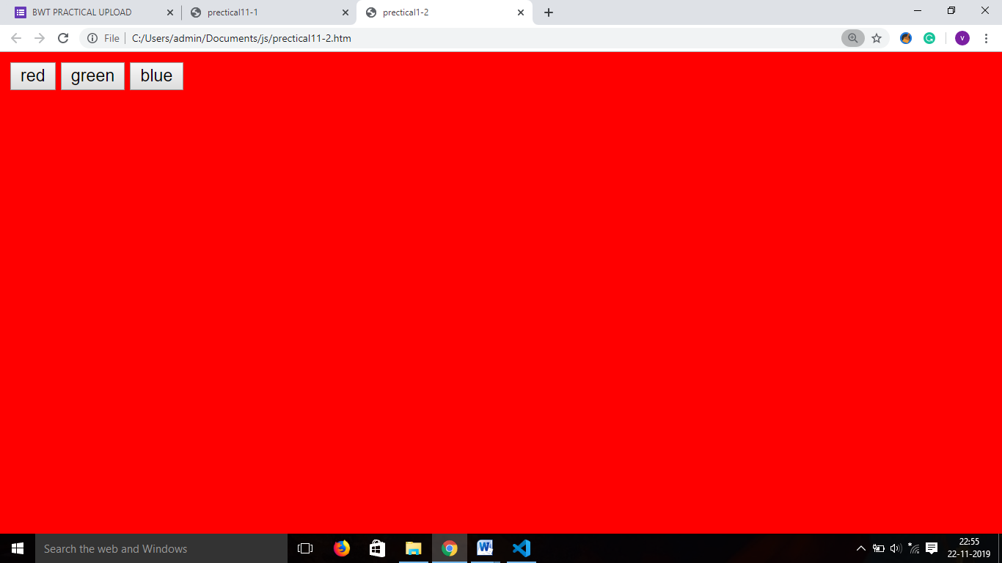

3.      Write a JavaScript to find out the greatest number from three numbers.

**Source:**

<html>

<head>

<script type="text/javascript">

function max(form1){

var a=document.form1.a.value

var b=document.form1.b.value

var c=document.form1.c.value

if(a>b && a>c){

alert("a is greater");

}

else if(b>a && b>c)

{

alert("b is greater");

}

else{

alert("all are equal");

}

}

</script>

<title>prectical11-3</title>

</head>

<body>

<form name=form1>

Enter a:<input type="text" name="a"/>

Enter b:<input type="text" name="b"/>

Enter c:<input type="text" name="c"/>

<input type="button" value="max" onclick="max()"/>

</form>

</body>

</html>

**Output:**

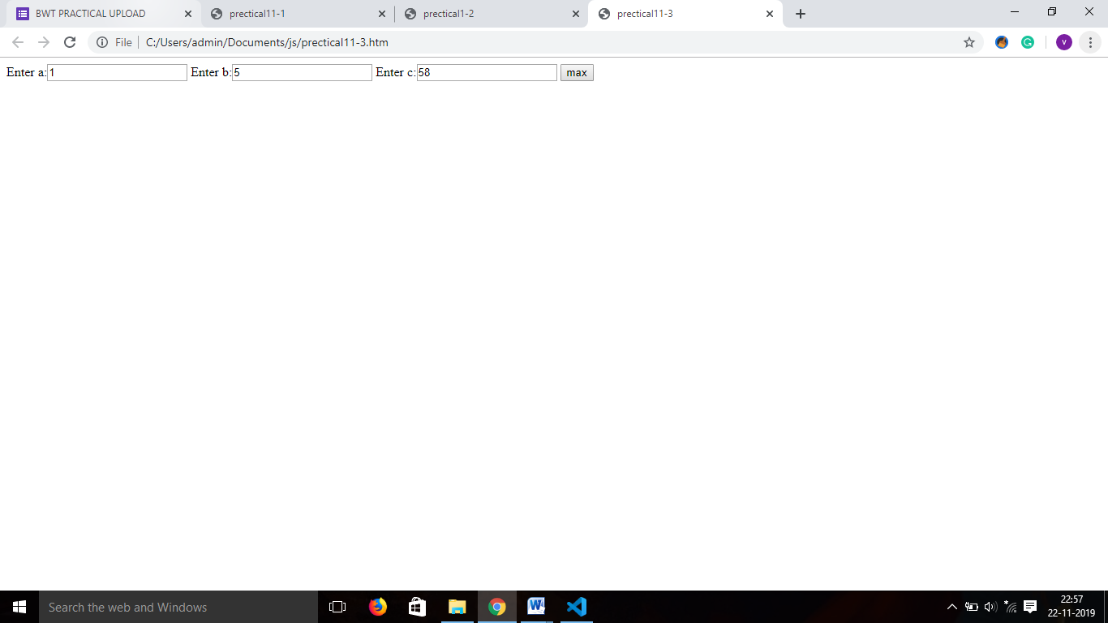

4.      Write a JavaScript to find weather the entered number is even or odd.

 <html>

<head>

<script type="text/javascript">

function check()

{

var a=document.getElementById("x").value;

if(a%2==0)

{

document.getElementById("a").innerHTML ="even";

}

else

{

document.getElementById("a").innerHTML ="ODD";

}

}

</script>

<title>prectical11-4

</title>

</head>

<body>

<form>

<input type="text" id="x">

<input type="button" VALUE="CHECK" onclick="check()">

<p id="a"></p>

</form>

</body>

</html>

**Output:**

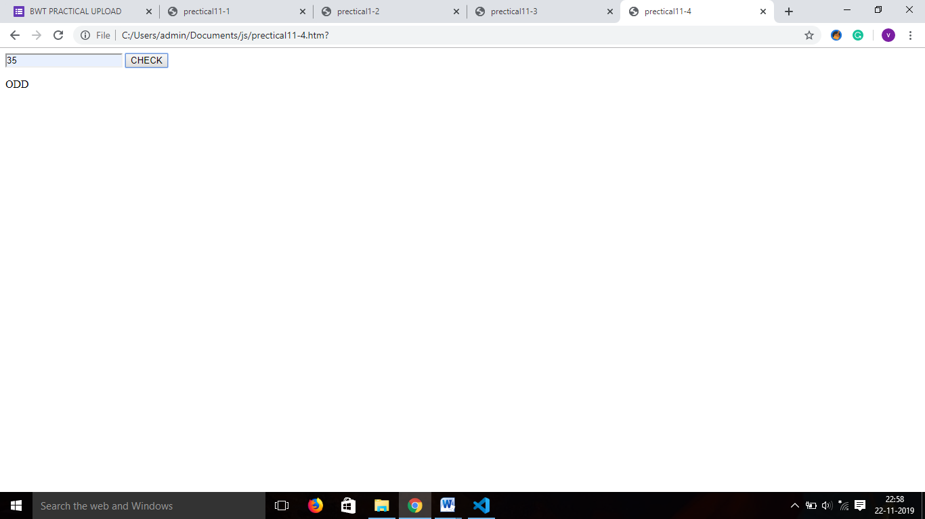

5.      Write a JavaScript to generate Fibonacci series up to user choice.

**Source:**

<html>

    <head>

        <title></title>

    </head>

    <script>

        {

    var a=0;

    var b=1;

    var c=a+b;}

    document.write(a);

    document.write(b);

    var n=0;

    var choice= prompt();

    while(n<=choice)

    {

        c=a+b;

        a=b;

        b=c;

        document.write(c);

        n++ }

    </script>

</html>

**Output:**

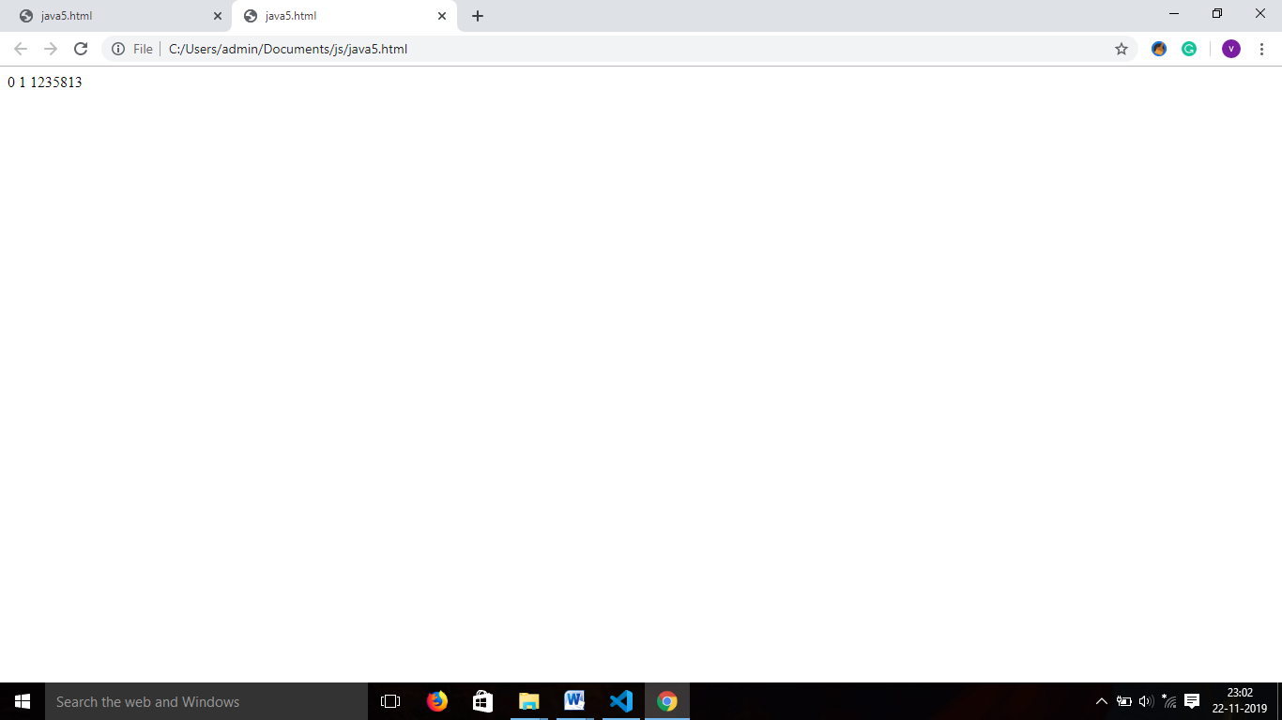

6.      Write a JavaScript to find weather the entered number is prime or not.

<html>

<head>

<script type="text/javascript">

function prime()

{

var a=document.getElementById("x").value;

var i=0;

var flag=1;

for(i=2;i<a;i++){

if(a%i==0)

{

document.getElementById("a").innerHTML ="not prime";

break;

}

else{

document.getElementById("a").innerHTML ="prime";

}

}

}

</script>

<title>prectical11-6

</title>

<body>

<p>Enter a:</p><input type="text" id="x"><br>

<input type="button" value="submit" onClick="prime()">

<p id="a"></p>

</body>

</html>

**Output:**

7.      Write a HTML code design following form and display all textbox value in single message box.

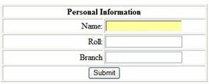

**Source:**

<html>

<head>

<script type="text/javascript">

function information(){

 var a=document.getElementById("a").value;

 var b=document.getElementById("b").value;

 var c=document.getElementById("c").value;

confirm("name is :-"+a+ "\n roll no is :-" +b+ "\n branch is :-"+c );

}

</script>

<title>prectical11-7</title>

</head>

<body>

<form>

<p=center>Personal Information</p>

<p>Enter Name:</p><input type="text" id="a"><br>

<p>Roll no:</p><input type="text" id="b"><br>

<p>Branch:</p><input type="text" id="c"><br>

<input type="button" value="submit" onClick="information()">

</form>

</body>

</html>

**Output:**

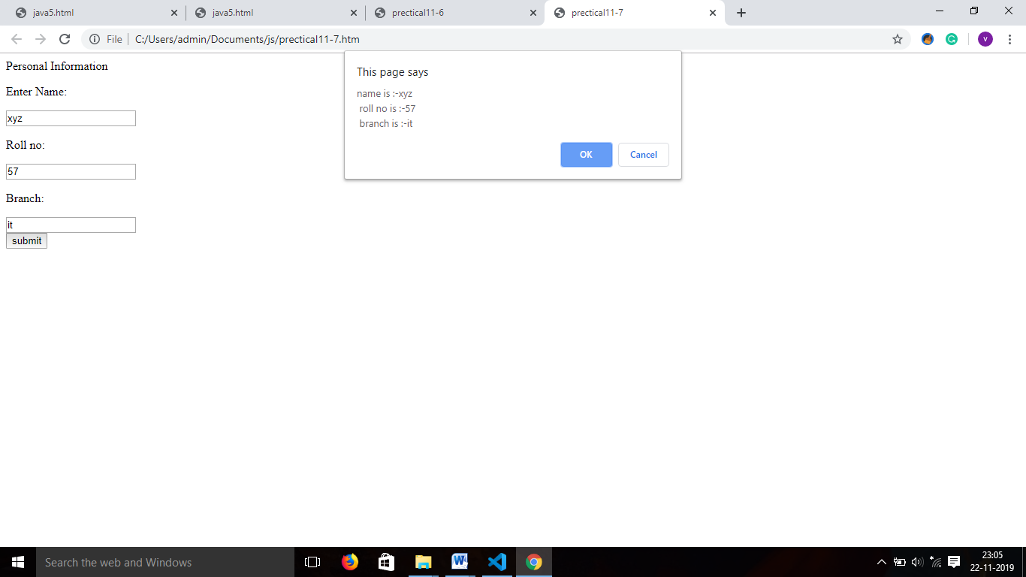

8.      Write a JavaScript to display system date in DD/MM/YYYY format.

**Source:**

<html>

<head>

<script type="text/javascript">

function date(){

var x=new Date();

var dd=x.getDate();

var mm=x.getMonth();

mm=mm+1;

mm='0'+mm;

var yy=x.getFullYear();

document.getElementById("demo").innerHTML=dd+"/"+mm+"/"+yy;

}

</script>

</head>

<body>

<p id="demo"></p>

<p id="demo1"></p>

<p id="demo2"></p>

<input type="button" value="getdate" onClick="date()">

</body>

</html>

**Output:**

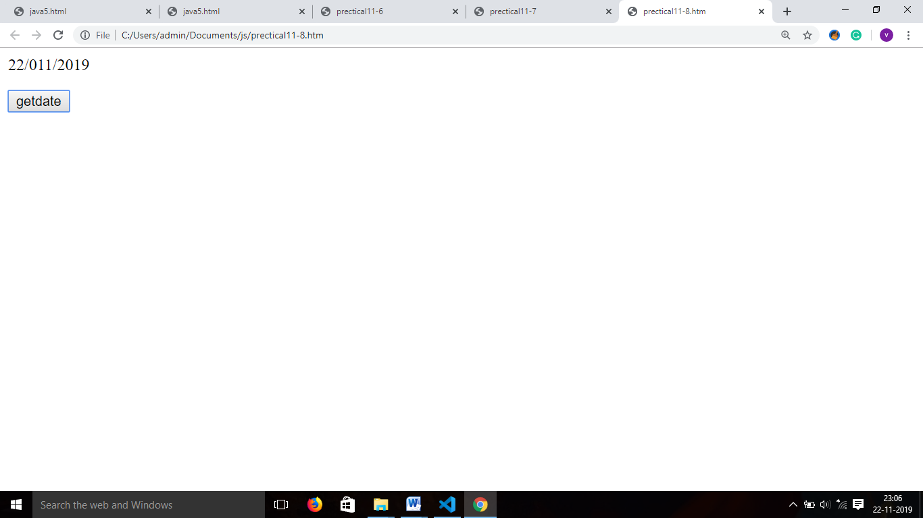

9.      Write a JavaScript to display appropriate message according to system time.

**Source:**

<html>

<head>

<script type="text/javascript">

function sys(){

var d=new Date();

var n=d.getHours();

var m=d.getMinutes();

alert(n);

if(n>=0&&n<12){

document.write("good morning");

}

else if(n>=12&&n<=16){

document.write("good afternoon");

}

else if(n>16&&n<=19){

document.write("good evening");

}

else{

document.write("good nigtt")

}

}

</script>

<title>msg</title>

</head>

<body>

<input type="button" value="getmsg" onClick="sys()">

</body>

</html>

**Output:**

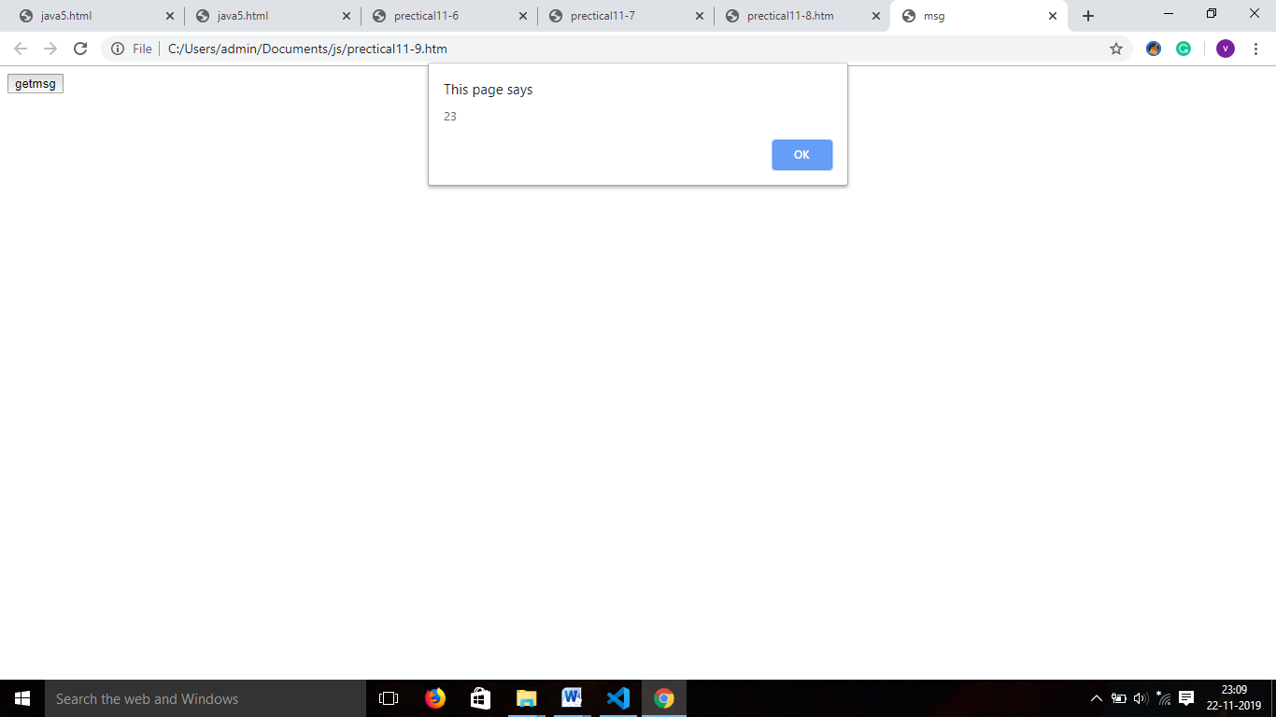

10. Write a JavaScript to find pattern string according to starting and ending position of the given string and display it in Uppercase with font color is blue.

**Source:**

<html>

<head>

<script type="text/javascript">

function upper()

{

var str=document.getElementById("c").value;

if(str.match(/[q].*[t]$/ig)){

var x=str.toUpperCase();

document.getElementById("a").innerHTML=""+x;

document.getElementById(�a�).style.color = "blue";

}

else{

document.getElementById("b").innerHTML="Not Match";

}

}

</script>

<title>prectical11-10</title>

</head>

<body>

<input type="text" id="c">

<input type="button" value="submit" onClick="upper()">

<p id="a"></p>

<p id="b"></p>

</body>

</html>

**Output:**

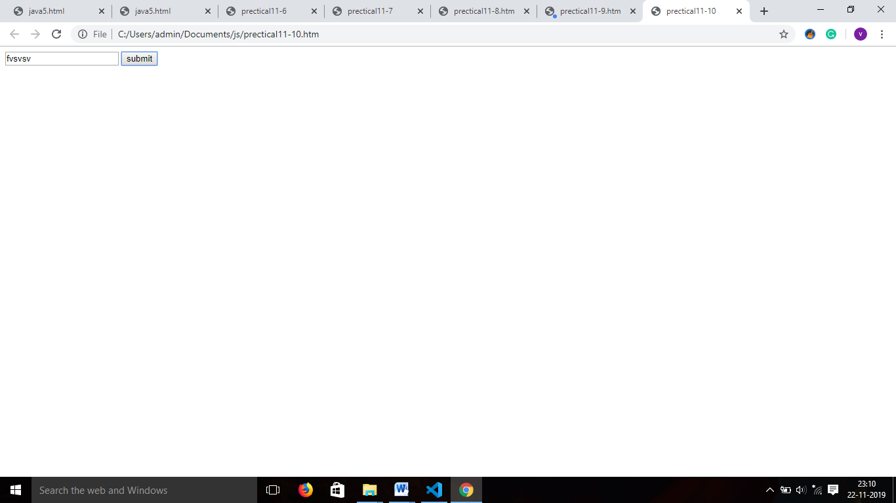

11. Write a HTML code design following form and display all value in single message box with validation:

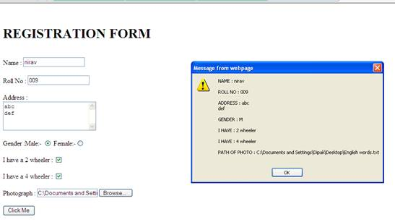

**Source:**

<html>

<head>

<script type="text/javascript">

function fe()

{

    var x=document.getElementById("name").value;

    var y=document.getElementById("roll").value;

    var z=document.getElementById("add").value;

    var a= document.getElementById("a").value

    confirm("name ="+x+"\nroll =" +y+"\nAddress ="+z);

}

function a()

{

    document.getElementById("name").style.background="yellow";

}

function b()

{

    document.getElementById("roll").style.background="yellow";

}

function c()

{

    document.getElementById("add").style.background="yellow";

}

function d()

{

    document.getElementById("a").value

}

</script>

</head>

<body>

<form>

    Name:<input type="text" id="name" onfocus="a()"><br>

    Roll NO:<input type="text" id="roll" onfocus="b()"><br>

    Address:<input type="text" id="add" onfocus="c()"><br>

    Gender:<br><input type="radio" id="g" onfocus="c()" value="male">males

        <input type="radio" id="a" onfocus="c()" value="female">female<br>

    <input type="button" value="submit" onclick="fe()">

</form>

<b id="result">

</body>

</html>

**Output:**

